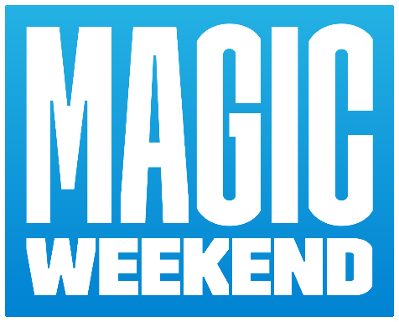

MAGIC WEEKEND 2022
SPECTATOR INFORMATION
SATURDAY 9 JUNE
WAKEFIELD TRINITY vs TOULOUSE OLYMPIQUE | 2:30pm
ST HELENS vs WIGAN WARRIORS | 4:45pm
LEEDS RHINOS vs CASTLEFORD TIGERS | 7:00pm
SUNDAY 10 JUNE
HUDDERSFIELD GIANTS vs SALFORD RED DEVILS | 1:00pm
CATALANS DRAGONS vs WARRINGTON WOLVES | 3:15pm
HULL KINGSTON ROVERS vs HULL FC | 5:30pm

TICKETING INFORMATION
Box Office Opening Times
Saturday: 11:00 – 20:00 | Sunday: 10:00 – 18:30
Ticket Collections
Milburn Stand Main Reception - VIP collections & hospitality
Stadium Box Office - General admission
Gallowgate Collection Windows – Sky VIP

END ALLOCATIONS
Leazes Stand
Saturday: Wakefield Trinity, St Helens, Leeds Rhinos
Sunday: Huddersfield Giants, Catalans Dragons, Hull KR
Gallowgate Stand
Saturday: Toulouse Olympique, Wigan Warriors, Castleford Tigers
Sunday: Salford Red Devils Warrington Wolves, Hull FC
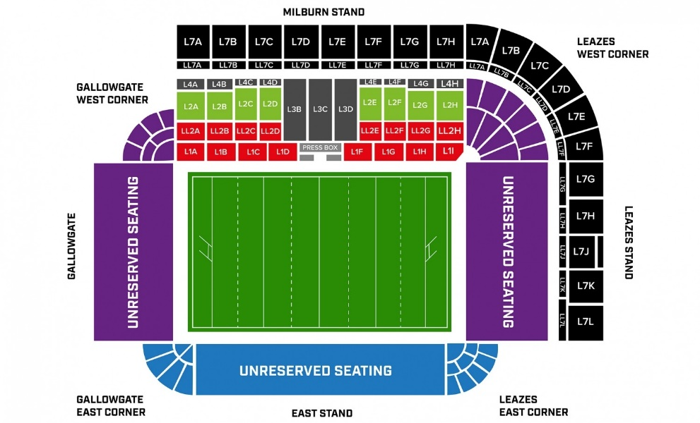
CATERGORY SEATING
Milburn Stand | Cat 1 - Reserved Seating
East Stand (inc Leazes East & Gallowgate East) | Cat 2 - Unreserved Seating
Gallowgate Stand (inc Gallowgate West) | Cat 3 - Unreserved Seating
Leazes Stand (inc Leazes West) | Cat 3 - Unreserved Seating

HOW TO GET THERE
For the smoothest possible journey, we recommend visiting: www.altoonativetravel.com
ON FOOT
St. James’ Park is located to the North West of Newcastle city centre, close to the junction between Gallowgate, St. James’ Boulevard and Barrack Road. That’s just a 10-minute walk from Newcastle Central Station and around five minutes from Monument Metro Station and the city’s major bus stations. You can get your very own tailor-made route at www.walkit.com.
BY CAR
Parking for the above mentioned vehicles is available on-site in the stadium car parks on a pre-pay basis only. To purchase a pass please contact NUFC on 0191 201 8558. Please note parking is limited, however there are number of public car parks signposted clearly within Newcastle city centre, though be warned – they are likely to be extremely busy during Magic Weekend! Information can be found on the Newcastle Council website. If you do need to use your car, use the postcode ‘NE1 4ST’ in your sat-nav to find the stadium.
BY METRO
Newcastle upon Tyne is served by the Tyne & Wear Metro system; a light rail network with frequent services between Newcastle Airport, Newcastle city centre, the coast, major transport interchanges and destinations south to Wearside. We recommend St. James’ Metro station for local coastal destinations including North Shields, while Monument station – a five-minute walk away – is served by both yellow and green line routes towards Newcastle International Airport, South Shields and the coast. To reach St. James’ Park from Monument station, walk west on Blackett Street and continue onto Gallowgate. The stadium will become visible on your right. For more information, please visit www.altoonativetravel.com/by-metro.
BY TRAIN
Newcastle Central Station is around a 10-minute walk from St. James’ Park. Situated on the East Coast Mainline, it is a principle stop for services between London and Edinburgh/Glasgow. In addition to regional services to Middlesbrough and Carlisle, it also offers direct cross-country routes to and from Leeds, Manchester, Liverpool Birmingham and Bristol. To walk to St. James’ Park, cross the road from the station and walk up Pink Lane to your left, passing the Forth Hotel public house. Turn right onto Clayton Street, then left onto Westgate Road. Outside Tilleys Bar, bear right onto Bath Lane and after 200 metres, turn right onto Stowell Street (Chinatown) and continue until the ground becomes visible beyond the Chinatown arch. To plan your train journey, please visit www.nationalrail.co.uk.
BY PUBLIC BUS
Newcastle upon Tyne has two major bus stations for local and regional services – Haymarket, for services to and from Northumberland and the North, and Eldon Square, for services to and from County Durham and the South. Both are located on Percy Street, a five-minute walk from St. James’ Park. To reach the stadium, walk south west on Percy Street and turn right onto Gallowgate. St. James’ Park will become visible on your right. For more information on local bus services, please visit www.altoonativetravel.com/by-bus. Newcastle Coach Station is on St. James’ Boulevard and receives National Express coach services, while Megabus operates services from outside Newcastle Central Station. Both offer frequent services from across the UK.
FAN COACHES
From A1 south – Follow signs for City West to B6324 junction, take 3rd exit from roundabout onto Stamfordham Road. Follow A167 City Centre to the Cow Hill junction. Exit and then turn right onto Grandstand Road then follow signs for City Centre. St James Park is on left hand side. Please park as directed on southbound carriageway. From A69 west – At A1 junction, follow signs for A1 North (Morpeth) then as above. There is a pay and display HGV and coach park on Ord Street by the Metro Radio Arena. For further information, please contact the Parking Department on 0191 261 4503 or visit the Newcastle Council website for parking in the city.
MINIBUSES
Routes to St James Park, as above. Drop-off only outside Stadium. For longer stay parking, return in same direction to crossroads adjacent to BBC. Turn right onto Hunters Road. Follow for ¼ mile to Claremont Road junction and turn left. Parking will be located on the right-hand side.

ONCE YOU’RE THERE
TICKETS
Please enter the stadium via the turnstile indicated on your ticket. The North (Leazes), East and South (Gallowgate) stands are for tickets with unreserved seating. The main West (Milburn) stand will accommodate supporters with reserved seats.
RESERVED SEATING
Spectators must ensure that they sit in their allocated seat(s). Although there may be adjacent seats that appear to be empty, it is likely that ticket holder hasn’t yet arrived or is elsewhere in the stadium.
UNRESERVED SEATING
It is important to note that if an unreserved seat is vacated, it may not be possible to return to the same seat at a later time. Certain seats or blocks within unreserved areas of the stadium bowl may be marked as RESERVED (e.g. close to wheelchair platforms and dug outs) and as such are not available to holders of unreserved seat tickets. Spectators should ensure that they do not sit in any seat marked reserved if they have purchased a ticket for an unreserved area.
IDENTIFICATION FOR CONCESSIONS
If a concessionary ticket has been purchased, identification may be requested on entry. Holders of such tickets should ensure that they have appropriate ID with them.
PASS OUTS
A pass out/return system will be operated on both event days allowing spectators to move freely to and from the stadium bowl – there is no limit on the number of times someone is allowed to pass out and re-enter.
Spectators leaving the stadium bowl with the intention of returning may do so but MUST first ensure that they have a hand stamp applied upon initial exit; if there is no evidence of a hand stamp re-entry will not be permitted. Hand stamps will be applied by stadium stewards.
Dedicated exit and re-entry gates in each stand will be used to facilitate this operation. Different coloured hand stamps will be used for each level each day. It is important that match tickets are not discarded; tickets need to be produced for re-entry if using the pass out system. Re-entry to the stadium bowl will be on production of both a hand stamp and relevant match ticket.
FAN ZONE
Opening Times: Saturday 11am – 7.30pm | Sunday 11am – 5.30pm
The Fan Zone is located on Strawberry Place, offering food, beverage, and activities delivered by official partners Dacia, Northern and Batchelors Mushy Peas throughout the weekend. Metro Radio will be hosting the fan zone, keeping the party going with live music and special guest interviews from the stage at the heart of the activity.
Be sure to visit for a chance to have your photo with the Betfred Super League and Rugby League World Cup trophy, purchase official Dacia Magic Weekend merchandise and win some exclusive Super League prizes with our official partners.

DISABLED SUPPORTERS’ ASSISTANCE
Accessible parking (for blue badge holders) is available to purchase direct from NUFC – advance application only. To apply for a pass please call 0191 201 8558. Vehicles will not be permitted to park in accessible spaces without an event specific pass – blue badge must also be displayed on arrival.
Day passes are £15 per vehicle, weekend passes £20 vehicle. Spectators with tickets for the Milburn stand Upper tier are advised that there are 140 stairs and 14 landings leading up to the seating area.
If you are disabled or have mobility issues, please ask a steward who will be happy to direct you to a lift. Any spectators who require audio commentary, please contact the Customer Service Centre at The RFL on 0844 856 1113, Monday –Friday, 9am-5pm.

OTHER INFORMATION
REFERESHMENTS
A range of hot and cold snacks, soft drinks and alcohol will be available to purchase in all concourse areas. Once purchased within the stadium, alcohol cannot be taken outside into the city. While some kiosks do accept cash within the concourse area, we encourage fans, where possible, to bring a credit or debit card to purchase refreshments. The majority of kiosks within St James’ Park are CASH-LESS.
Please note that no large amount of food can be taken inside the stadium from outside. The amount of food allowed will be at the discretion of Newcastle United staff. Bottles and cans are also not permitted. If you have specific dietary requirements, please contact the steward at your stadium entry point. Permission may be granted following appropriate checks.
DISABLED TOILETS
There are disabled toilets in all supporter areas of the stadium which can be opened with a radar key. Please contact your nearest steward for assistance.
LUGGAGE/PUSHCHAIRS
We regret to inform you that there are no areas to store luggage and/or pushchairs at St. James’ Park during Magic Weekend. Luggage items larger than A4 size are not allowed into the stadium for security reasons. Appropriate discretion will be used for ladies’ handbags, baby changing bags, etc. and will be subject to the standard security checks.
QUIET ROOM
There is a quiet room available should anyone wish to use this space for practising multi-faith or quiet reflection. If you need to use this room, please alert your nearest steward who will direct you to this room.

